|  |  |
| --- | --- |
| EGC_Black | Student Name \_\_\_\_\_\_\_\_\_\_\_\_\_\_\_\_\_\_\_\_\_\_\_    **Eastern Goldfields College**  Mathematics Essentials U3&4 2016  Test 3 1 |
| **Working Time: 55 minutes** | **Total Marks: 48 marks** |

**Calculators allowed. Show all working where necessary to maximize your marks.**

**Question 1** [6 marks: 2, 2, 1, 1]

1. In the context of data collection, what is a census?
2. The Australian Government conducts a census every 5 years. What is the purpose of this census?
3. State one advantage of conducting a census.
4. State one disadvantage of conducting a census.

**Question 2** [3 marks]

The purpose of sampling as a method of data collection, is to provide an estimate of population values or characteristics.

State one method of sampling, explain what it is and how it could be done to gather data.

**Question 3** [5 marks – 1, 1, 2, 1]

The diagrams below represent an arrangement of tables and chairs.

This is summarized in the table below.

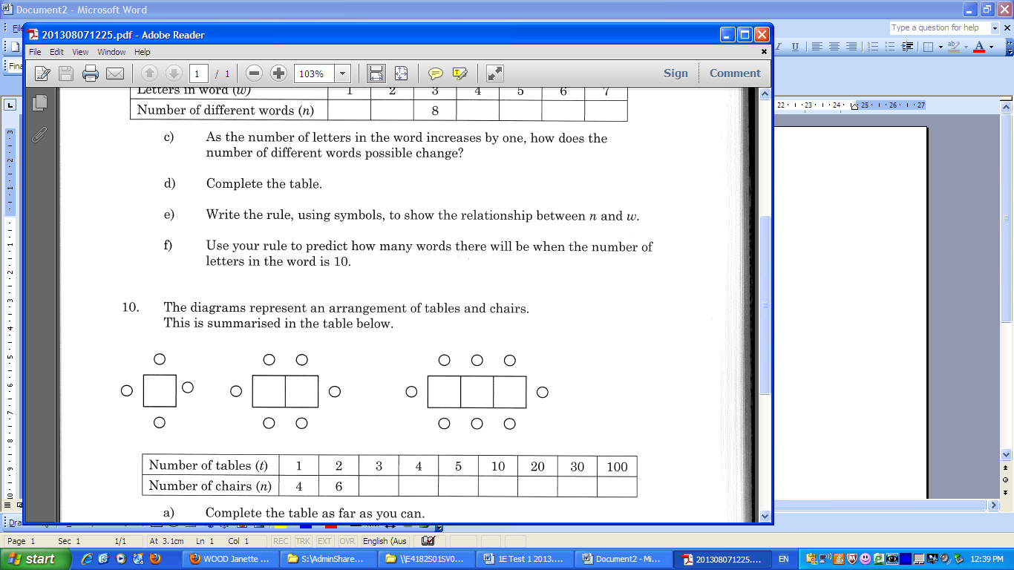

1. Draw the next diagram in the pattern.
2. Complete the table for values for t = 3 and t = 4.

|  |  |  |  |  |  |  |  |  |
| --- | --- | --- | --- | --- | --- | --- | --- | --- |
| Number of tables (t) | 1 | 2 | 3 | 4 | 5 | 10 | 20 | 100 |
| Number of chairs (n) | 4 | 6 |  |  |  |  |  |  |

c) Write a rule linking t and n

d) Complete the table above

**Question 4** [11 marks – 3, 1, 1, 2, 1, 2, 1]

The table below shows the length and diameter of a small sample of bird eggs from different species of birds.

|  |  |  |  |  |  |  |  |  |  |  |  |  |  |  |  |
| --- | --- | --- | --- | --- | --- | --- | --- | --- | --- | --- | --- | --- | --- | --- | --- |
| length (mm) | 95 | 18 | 29 | 70 | 66 | 11 | 86 | 101 | 15 | 135 | 43 | 147 | 150 | 153 | 140 |
| diameter (mm) | 62 | 13 | 21 | 47 | 42 | 8 | 60 | 70 | 13 | 81 | 34 | 110 | 124 | 133 | 89 |

a) Construct a scatterplot for the data.



b) State the dependent and independent variables.

Dependent : \_\_\_\_\_\_\_\_\_\_\_\_\_\_\_\_ Independent : \_\_\_\_\_\_\_\_\_\_\_\_\_\_\_\_

c) Describe the relationship between length and diameter for the dataset.

d) Draw a line of best fit and use it to predict the diameter of an egg with a length of 50 mm.

e) Predict the diameter of an egg with a length of 160 mm.

f) Which answer is likely to be more reliable/accurate – (c) or (d)? Explain why.

g) Describe the trend of the data.

**Question 5** [5 marks – 2, 3]

a) Given these three scattergraphs, which one shows the strongest linear relationship?

Justify your answer.

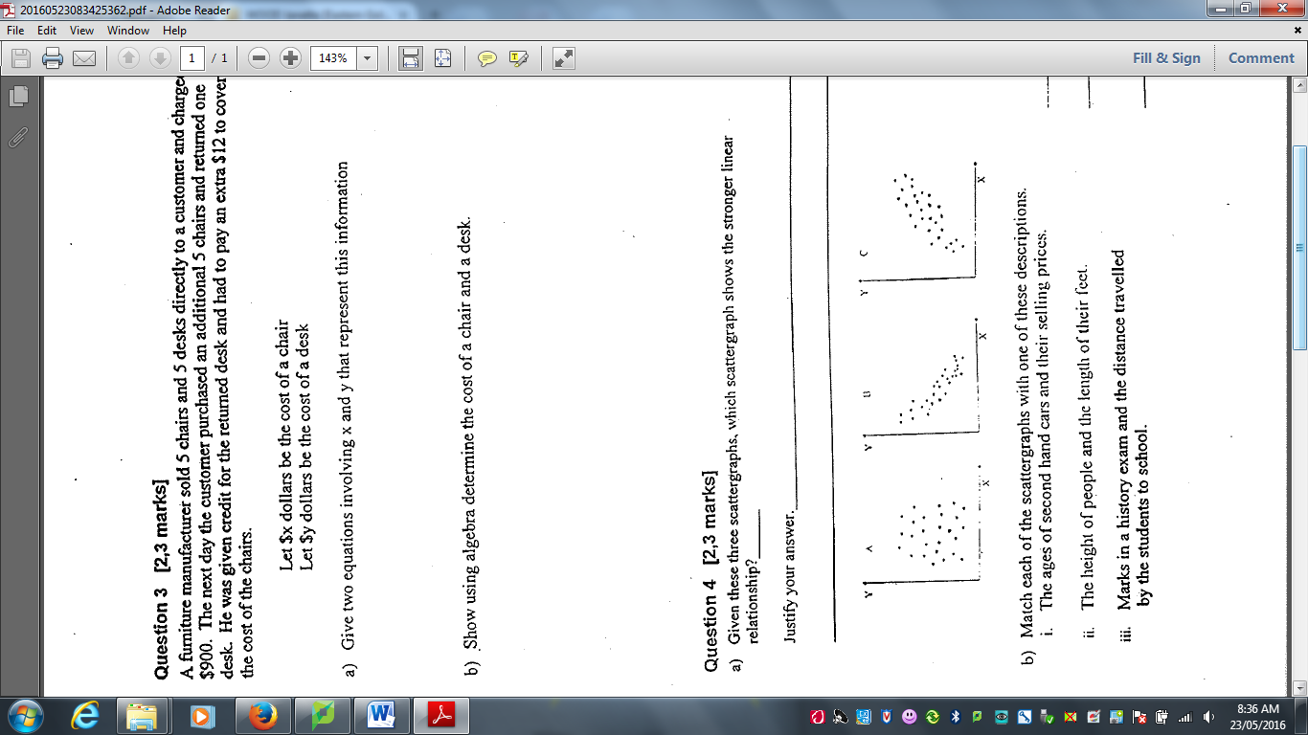

b) Match each of the scattergraphs with one of these descriptions.

i) The ages of second hand cars and their selling price

ii) The height of people and the length of their feet

ii) Marks in a history exam and the distance travelled by the students to school.

**Question 6** [5 marks]

State the coordinates of each point.

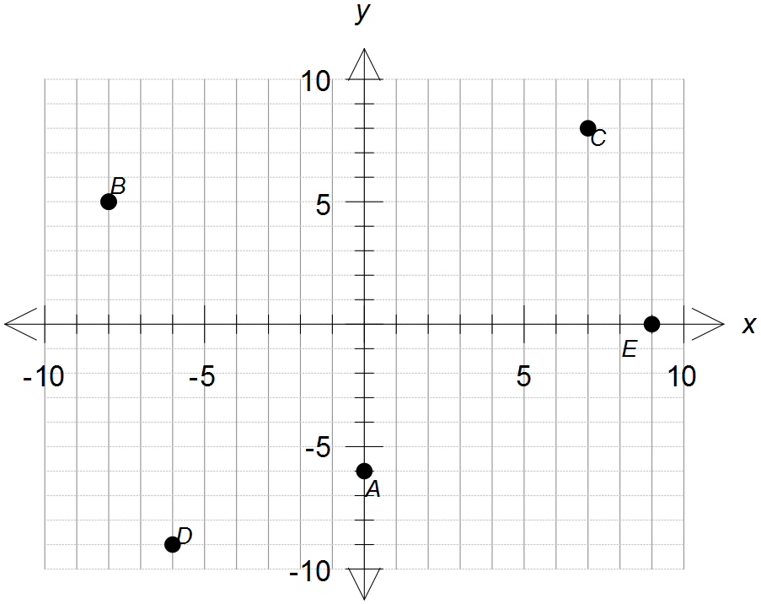

A

B

C

D

E

**Question 7** [2 marks]

The following graph shows the motion of a runner on a path.

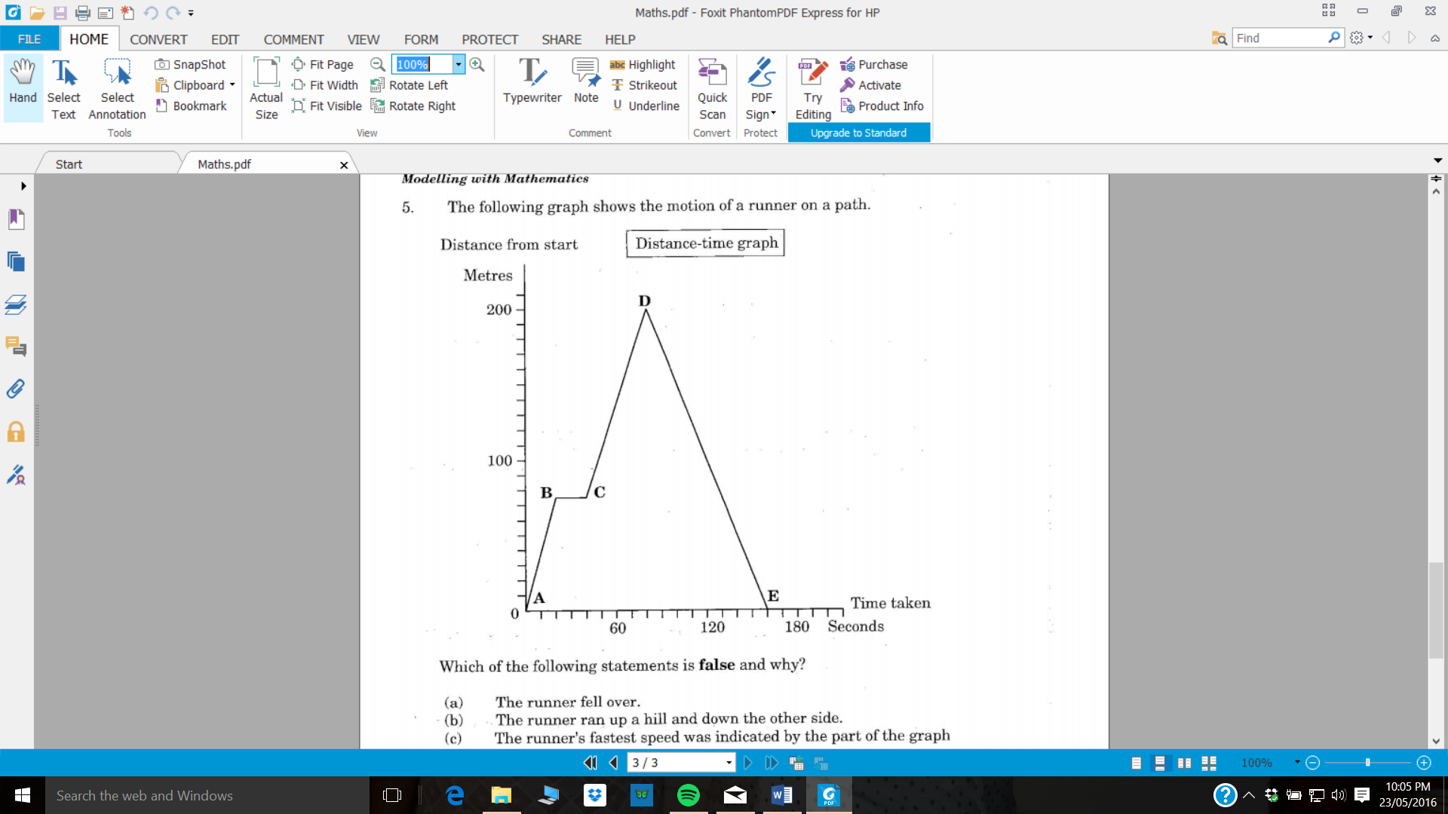

Which of the following statements is **false** and why?

1. The runner fell over.
2. The runner ran up a hill and down the other side.
3. The runner’s fastest speed was indicated by the part of the graph marked AB.
4. The runner’s average speed was the same as the speed indicated by the part of the graph marked DE.

**Question 8** [7 marks – 2, 1, 2, 2]

Shane is paid a retainer (fixed amount when no sales are made) and a commission on the value of his sales. His work involves getting people to sign up for holidays.

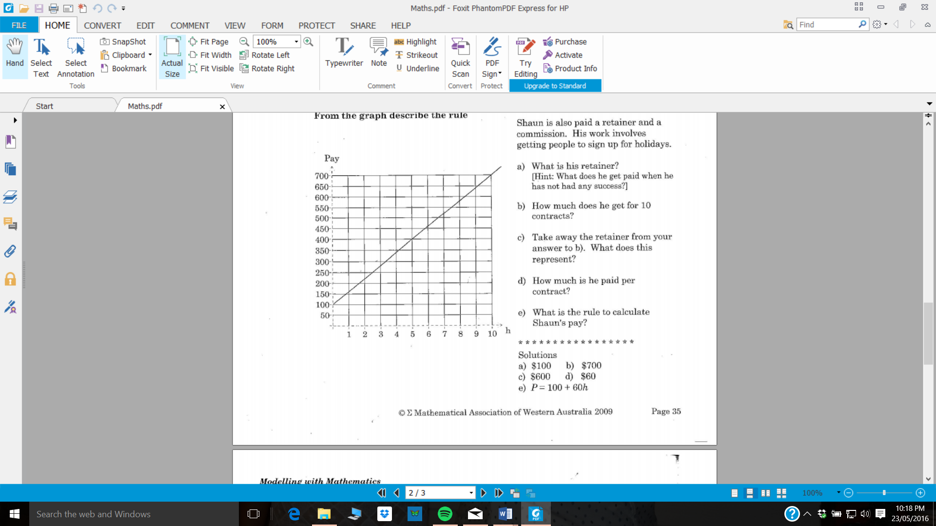

Holidays

1. What is his retainer and what feature of the graph indicates this?
2. How much does he earn for 10 contracts?
3. What is the gradient of the line and what does this represent in the context of this situation?
4. What is the rule in terms of ‘h’ to calculate Shane’s pay (P)?

**Question 9** [4 marks – 2, 2]

The data below was gathered from the 2011 Census and the 2006 Census.

**Western Australia – Dwellings**

|  |  |  |
| --- | --- | --- |
|  | **2011** | **2006** |
| **Total dwellings** | 963,325 | 851,163 |
| **Occupied private dwellings** | 851,393 | 757,990 |
| **Dwelling structure** | Separate house – 78.1% | Separate house – 78.6% |
| Flat/Unit/Apartment – 8.8% | Flat/Unit/Apartment– 8.5% |
| Semi-detached – 10.8% | Semi-detached – 10.6% |
| **Tenure** | Owned outright – 29.5% | Owned outright – 31.4% |
| Owned with mortgage – 37.8% | Owned with mortgage – 37.6% |
| Rented – 29.2% | Rented – 27.2% |
| **Household composition** | Single/multi-family household – 72.2% | Single/multi-family household – 71.7% |
| Lone person household – 23.8% | Lone person household – 24.7% |
| Group household – 4.0% | Group household – 3.6% |
| **Median household rent (weekly)** | $300 | $170 |
| **Median household mortgage repayments (monthly)** | $1,950 | $1,213 |
| **Average people per household** | 2.6 | 2.5 |
| **Average people per bedroom** | 1.1 | 1.1 |

1. What is the percentage increase in the median household rent from 2006 to 2011?
2. In 2011, what percentage of total dwellings were occupied private dwellings?

**END OF TEST**